***Assignment#02***

***Waqas ashiq***

***f-11-bcs-201***

***section c***

Q=1

#include<stdio.h>

void main()

{

int a;

printf("enter integer=");

scanf("%d", &a);

if(a%2 == 0)

{

printf("even\n");

}

else

{

printf("odd\n");

}

}

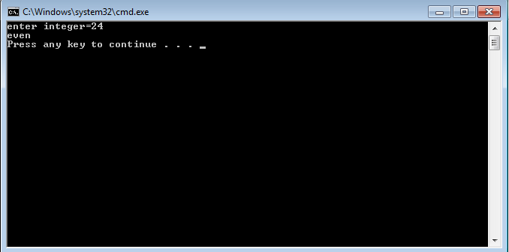

Start point

Print odd

odd

Print even

input

True

False

Else

joint

Merge

Q#2

#include<stdio.h>

void main()

{

int weight;

int height;

int bmi;

printf("enter weight=");

scanf("%d", &weight);

printf("enter height=");

scanf("%d", &height);

bmi=weight/height;

if (bmi<=18.5)

{

printf("underweight\n");

}

else if(bmi>=18.6)

{

printf("normal\n");

}

else if(bmi<=224.9)

{

printf("normal\n");

}

else if(bmi>=25)

{

printf("over weight\n");

}

else if(bmi<=29.9)

{

printf("over weight\n");

}

else if(bmi>=30)

{

printf("obese\n");

}

}

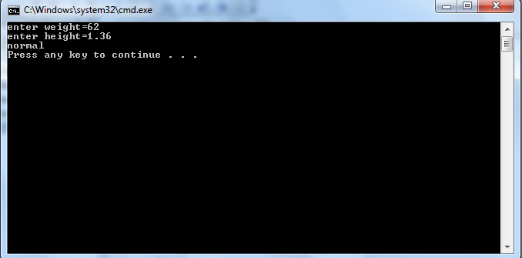

Starting point

Print output

Print output

Print output

Print output

process

Input

True

false

true

false

true

false

true

***Q#3***

#include<stdio.h>

int main()

{

int a=0;

while(a<10)

{

a=a+1;

printf("%d\t",a);

}

}

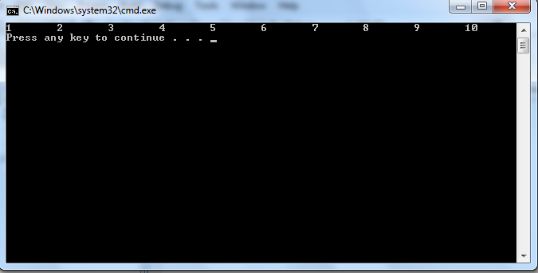

Start point

restatmnt

counter

Initialization

true

Print output

false

***Q#4***

#include <stdio.h>

int main()

{

float gallons;

float miles;

float mpg;

float total;

total=0;

int counter;

counter=0;

float average;

gallons=1;

while(gallons != -1)

{

printf("enter gallons or -1 to end=");

scanf("%f", &gallons);

if(gallons!=-1)

{

printf("enter miles=");

scanf("%f", &miles);

mpg= miles/gallons;

total= mpg+total;

counter++;

}

}

average=(float) total/counter;

printf("average is %f",average);

}

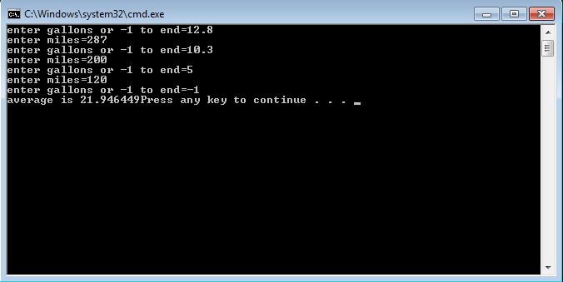

***Q#5***

#include<stdio.h>

int main()

{

int a=5;

a--;

printf("%d\n",a);

--a;

printf("%d\n",a);

}

